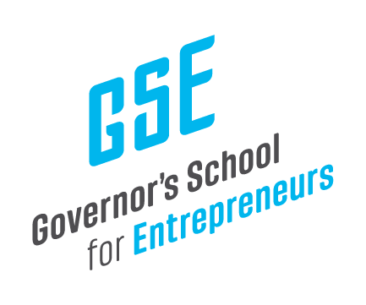

May 2, 2025

Mr. Jay Hartz
Legislative Research Commission Director
Sent Via Electronic Mail

Dear Mr. Hartz,

The Governor’s School for Entrepreneurs (GSE) is pleased to share the financial reports from our Second Quarter, covering the months of January, February, and March 2025 for FY 2025.

I welcome any questions or feedback on these reports.

Kind regards,

Anne

Anne Jewell
President & CEO
Governor’s School for Entrepreneurs

